**Cinema Application**

**Software Requirements Specification**

Version “Version Documentation”

**Submitted to:**

Nurlan Shaidullaev.

**Presented by “Software Team”:**

Askarbek Baiasov

Sanzhar Zhenishbek uulu

Daiyrbek Kanybekov

Saparbek Musaev

Daniel Akylbekov

Akylbek Mursaliev

# Revision History

|  |  |  |  |
| --- | --- | --- | --- |
| Date | Version | Description | Author |
| 27.02.2019 | 1.0 | Starting Creating of Document | Software Team |
| 12.03.2019 | 1.1 | Creating registration and profile System | Software Team |
| 20.03.2019 | 2.0 | Creating Movie description and price | Software Team |
| 27.03.2019 | 2.1 | creating booking places in cinema and description in profile page | Software Team |
| 3.04.2019 | 3.0 | Creating places in cinema and tips of movie | Software Team |
| 10.04.2019 | 3.1 | Creating date of movie and update movie | Software Team |
| 24.04.2019 | 4.0 | Creating movie add function and cinema choose function | Software team |

# Table of Contents:

Revision History

Table of Contents

Introduction

Project Description

Purpose

Scope

Definition, Acronyms and Abbreviations  
 Developing team description

References

Overall Description

Problem Statement

Background

Objectives

Constraints

Functional Requirement

Use Cases

**Diagrams**

User Requirements

Technical Requirements

Performance

Scalability

Security

Maintainability

Usability

Localization Support

Auditing and Logging

Availability

Hardware Requirements

Network

Client Computers

Deployment Requirements

Nodes

Components

Artifacts

Other Requirements

Appendices

Screenshots

**Introduction**

## This technical document includes all structures of the project just like a chronological as well as the logical structure with all scenarios and all areas of application.

## This document also will be a short manual of using application and system requirement for the correct operation of the application system

## The main purpose of this document is to provide the general work plan and analysis of the project.

**Project Description:**

This project aims to provide customers with the opportunity to book tickets to cinemas online, through which they can book tickets anytime and anywhere. The Cinema application is primarily designed to provide clients with a service anytime, anywhere to reserve a seat in a cinema and collect information about movies on the Internet. The user can easily find out about the released films, and then make a choice. A cinema management system, online ticketing software that is easy to understand, easy to use, and offers customers a simple, quick, select-and-click service.

## Purpose

The main purpose of this document is to provide the full description about our project to full provision of the product to the end user. It is assumed that the consumer will be much faster to study and use the product due to the presence of the necessary manuals and instructions for use.

## Scope

## The project focuses on the developing in range of Kyrgyz - cinema.

## The project in regarded as a business platform for business.

**User Stories**

**[https://easybacklog.com/accounts/28020/backlogs/309934](http://easybacklog)**

## Definition, Acronyms and Abbreviations

|  |  |
| --- | --- |
| Term | Definition |
| Android Studio Platform | There are many **platforms**, like **Android Studio**, where even beginners can get into **Android** development. **Android Studio** is a cross-**platform** integrated development environment (IDE) for developing on the **Android platform**. It is written in Java and is available for Linux, Windows as well as for Mac OS X |
| Java Programming Language | **Java** is a general-purpose **programming language** that is class-based, object-oriented, and designed to have as few implementation dependencies as possible. ... **Java** applications are typically compiled to "bytecode" that can run on any **Java** virtual machine (JVM) regardless of the underlying computer architecture. |
| Xml design | **XML** stands for Extensible Markup Language. **XML** is a markup language much like HTML used to describe data. ... In this article we will go through the basic concepts of **xml** in **Android** and different **XML** files used for different purpose in **Android**. This will help you in writing a UI code to **design** your desired user interface. |
| Cloud FireStore | Cloud Firestore is a NoSQL document-based database that was built specifically for mobile and web application development. It leverages Google's powerful cloud infrastructure and lets users easily store, sync, and query data in real-time with low latency, all at a global scale |

## Development team Description:

Project manager: Askarbek Baiasov([askarbek.baiasov@iaau.edu.kg](mailto:askarbek.baiasov@iaau.edu.kg))

Developer: Sanzhar Zhenishbek Uulu ([sanzhar.jenishbekuulu@iaau.edu.kg](mailto:sanzhar.jenishbekuulu@iaau.edu.kg))

Developer: Saparbek Musaev([saparbek.musaev@iaau.edu.kg](mailto:saparbek.musaev@iaau.edu.kg))

Developer: Daiyrbek Kanybekov([daiyrbek.kanybekov@iaau.edu.kg](mailto:daiyrbek.kanybekov@iaau.edu.kg))

Tester: Daniel Akylbekov([daniel.akylbekov@iaau.edu.kg](mailto:daniel.akylbekov@iaau.edu.kg))

Requirement Engineer: Akylbek Mursaliev([akylbek.mursaliev@iaau.edu.kg](mailto:akylbek.mursaliev@iaau.edu.kg))

## References

Just Software-Requirements-Specification-template File from the OCS.IAAU.EDU.KG.

Information from internet

# 

# Overall Description

## 

## Problem Statement

Queue at the box office, Time management, Choice of cinemas, Suitable films

## Background

The problem which everyone meets in their lives is the going to the cinema. In this time no clean platform which everyone uses to book the tickets online. But in our country we have a platform like this called - "cinematica". But many peoples not using this platform with their difficultness to understand. Peoples can’t organize their time managements and go to the cinema whenever they want. And we started creating this platform for booking cinema tickets online to solve this problem. Using this platform, you can easily choose the cinema choose the time and go to watch whenever you want.

**Objectives**

Through this project we present a comprehensive solution for ticket booking inmultiplexes.This powerful and**r**oid application is specifically designed for theater owners,to s**ell tickets online. Therefore, t**hemain objective of Cinema Application is **to** develop an enhanced, automated, accurate, user-friendly and less maintained way.

**Constraints**

The opportunity to unleash their full potential within the borders of one state.

**Functional Requirements**

## Use Cases

|  |  |
| --- | --- |
| Use Case | Description |
| Unregistered User | Unregistered user in a first page will see  Home,  Now Showing,  Up Coming pages |
| Unregistered User | Unregistered user can see genres of the movie list and see how many genres are there. |
| Unregistered User | Choose any movie and Read the description of the movie and watch the trailer of the movie. |
| Unregistered User | Choose any movie and watch the trailer of the movie. |
| Unregistered User | Unregistered user can see how much the tickets costs. |
| Unregistered User | Unregistered user can’t book the tickets online. |
| Registration: get into application | Unregistered user must register for booking the tickets. |
| Registration | User can register in the registration page. |
| Registration | After registration user can book the tickets, choose the cinema and see the free places in cinema. |
| Registration | If user forgot or lost the password, user can change it. |
| User Profile | After registration will open the user profile for user. |
| User Profile | All information about user and user booking history will be in user profile. |
| User Profile | All information about user booking will show in user profile |
| Admin | Admin have a functions Movie management. |
| Admin | Admin have a function Cinema Management |
| Admin | Admin have a function Add/Update Show Time. |
| Booking Tickets | Registered user can book the tickets to watch movie |
| Booking Tickets | Choose the movie which user going to watch |
| Booking Tickets | Read the description of the Movie or watch the trailer of the movie. |
| Booking Tickets | Choose any time to watch movie in the cinema and choose the cinema |
| Booking Tickets | Choose the free places from the cinema and book the ticket. |
|  |  |

**Admin**

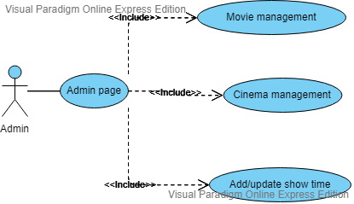

**Registration User:**

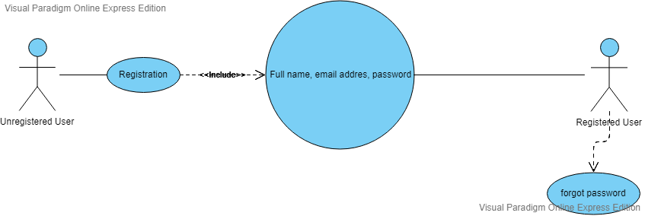

**Unregistered User:**

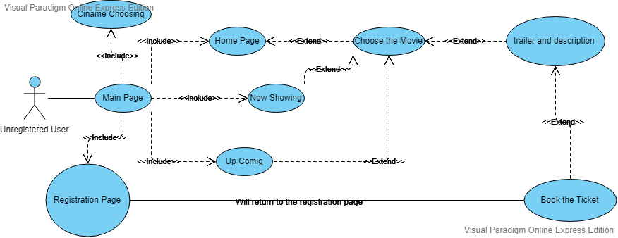

**Registered User:**

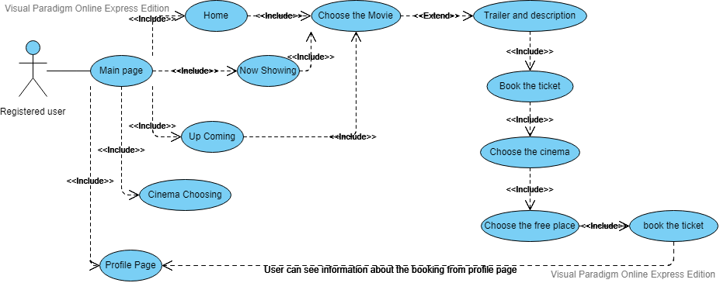

**Use case Diagram:**

C:\Users\akylb\OneDrive\Документы\Use case deagram.png

**Activity Diagram:**

C:\Users\akylb\OneDrive\Документы\Activity Diagrams.png

**Sequence Diagrams**

**Sequence diagrams for Cinema App.**

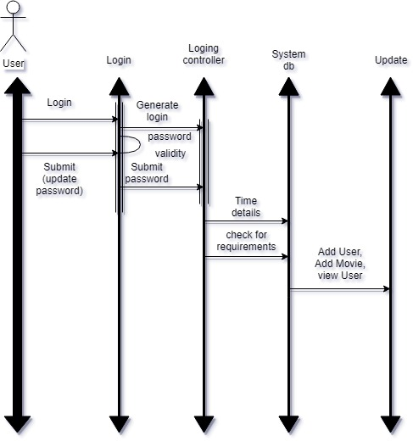

# User Requirements

|  |  |
| --- | --- |
| Actor | Description |
| Admin | Admin can manage movies such as Add, Edit, hide/show.  Admin can manage movie schedule such as Add, Edit, hide/show.  Admin can manage show such as change in Show Name and Show Time. |
| Booking tickets | After login, user can book ticket directly by following ways:  User can book ticket by selecting Movie.  User can book ticket by selecting Theatre.  User can book ticket by selecting Time |
| User | User can Register.  User can Login.  User can Check Availability.  User can Book Ticket |

# Technical Requirements

## Performance

Android Application without any serious system requirement for use

required a stable internet

## Scalability

The public

Can be imported to the website

Can be imported to the IOS application

Not limited to one cinema

## Security

Integrated protection within the service followed by a protocol for it.

## Maintainability

Included, automated

Service in due time stops the work, in case of need of repair, warning about it.

## Usability

Cinema Application is basically made for providing the customers an anytime and anywhere service for booking the seat in the cinema hall and to gather information about the movies online. The user can easily be able to know about the movies released and then make the choice.

## Localization Support

English

## Availability

email with the further integration of Google services

# Hardware Requirements

## 

## Network

stable internet connection

## Client Computers

Android smartphones

**Screenshots:**

